**The Trapezoidal Rule Redux**

The homework was to solve for the approximate integral of *f(x) = x+2*x*cos(x2)* given the limits 1<x<5 and that there are 16 Divisions. Using both Matlab and excel and comparing to the already made Labview data to ensure consistency and some accuracy.

**Matlab:**

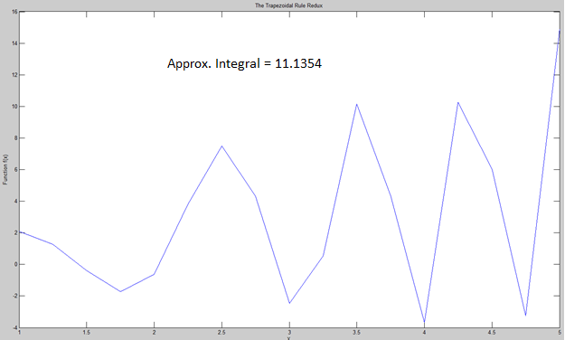

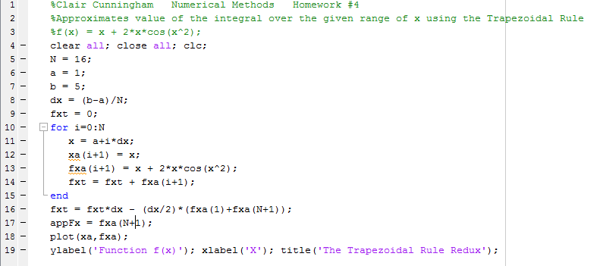

**Excel:**



**Labview:**

